### 2.5. Algorithm Analysis

In this section, the libraries identified with the work will be talked about from a technological perspective and break down every library contrasted with our area and the research territory

### **2.5.1Machine Learning Approach**

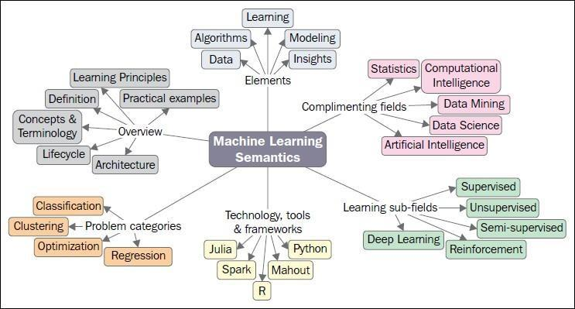

Figure 3:Machine Learning Semantics

Machine learning is a data analytics tool which automates the creation of analytical models. This is a subset of artificial intelligence focused on the premise that systems with minimal human input can learn from data, recognize trends and make decisions (Anon., 2019). Machine learnings focuses on the development of computer programs that can access data and use it learn for themselves. Machine-learning algorithms are using statistics to find patterns in huge quantities of data. And the data, here, includes a lot of things - numbers, words, pictures, clicks, what have you. If it can be digitally stored, it can be fed into a machine-learning algorithm. (Anon., 2019)

**2.5.1.1. There are typically three phases for performing Machine learning:**

**Phase 1—Training Phase**: This is the phase where training data is used to train the model by pairing the given input with the expected output. The output of this phase is the learning model itself.

**Phase 2—Validation and Test Phase**: This phase is to measure how good the learning model that has been trained is an estimate the model properties, such as error measures, recall, precision, and others. This phase uses a validation dataset, and the output is a sophisticated learning model.

**Phase 3—Application Phase**: In this phase, the model is subject to the real- world data for which the results need to be derived.

**2.5.1.2. Types of Machine learning systems**

There are so many different types of Machine Learning systems that it is useful to classify them in broad categories based on:

Whether or not they are trained with human supervision supervised/ unsupervised, semi supervised, and Reinforcement Learning)

Whether or not they can learn incrementally on the fly (online versus batch learning)

Whether they work by simply comparing new data points to known data points, or instead detect patterns in the training data and build a predictive model, much like scientists do (instance-based versus model-based learning)

Generally, the field of machine learning is divided into three subdomains: supervised learning, unsupervised learning, and reinforcement learning. Briefly, super- vised learning requires training with labeled data which has inputs and desired outputs. In contrast with the supervised learning, unsupervised learning does not re- quire labeled training data and the environment only provides inputs without desired targets. Reinforcement learning enables learning from feedback received through interactions with an external environment. (Jones, 2014)

### **2.5.1.2.1. Supervision supervised**

Machine Learning systems can be classified according to the amount and type of supervision they get during training. There are four major categories: supervised learning, unsupervised learning, semi supervised learning, and Reinforcement Learning. (Qiu et al., 2016)

In supervised learning, the training data you feed to the algorithm includes the desired solutions, called labels.

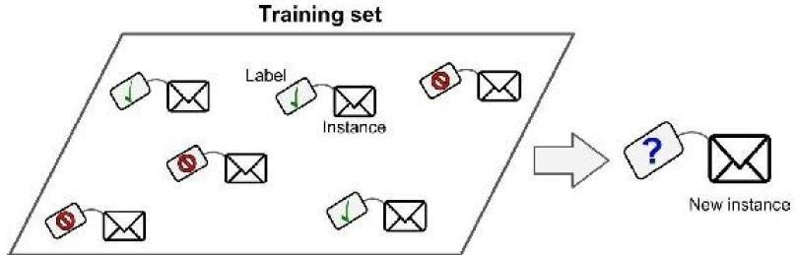

Figure 4:Training set for supervised learning

A typical supervised learning task is classification. The spam filter is a good example of this: it is trained with many examples emails along with their class (spam or ham), and it must learn how to classify new emails. Another typical task is to predict a target numeric value, such as the price of a car, given a set of features (mileage, age, brand, etc.) called predictors. This sort of task is called regression .1 To train the system, you need to give it many examples of cars, including both their predictors and their labels (i.e., their prices). (Qiu et al., 2016)

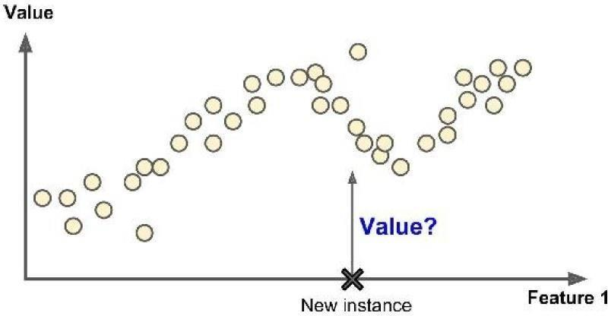

Figure 5:Regression

### **2.5.1.2.2. Unsupervised learning**

In unsupervised learning, as you might guess, the training data is unlabeled. The system tries to learn without a teacher.

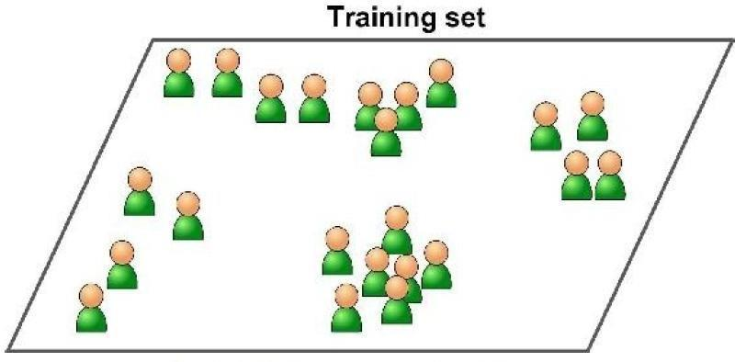

Figure 6:Unlabelled training set for unsupervised learning

In **unsupervised learning**, the dataset is a collection of **unlabeled examples**

{**x***i*}*Ni*=1. Again, **x** is a feature vector, and the goal of an **unsupervised learning algorithm** is to create a **model** that takes a feature vector **x** as input and either transforms it into another vector or into a value that can be used to solve a practical problem. For example, in **clustering**, the model returns the id of the cluster for each feature vector in the dataset. In **dimensionality reduction**, the output of the model is a feature vector that has fewer features than the input **x**; in **outlier detection**, the output is a real number that indicates how **x** is different from a “typical” example in the dataset. (Mitchell, 1997)

### **2.5.1.2.3. Semi supervised learning**

Some algorithms can deal with partially labeled training data, usually a lot of unlabeled data and a little bit of labeled data. This is called semi supervised learning . Some photo-hosting services, such as Google Photos, are good examples of this. Once you upload all your family photos to the service, it automatically recognizes that the same person A shows up in photos 1, 5, and 11, while another person B shows up in photos 2, 5, and 7. This is the unsupervised part of the algorithm (clustering). Now all the system needs are for you to tell it who these people are. Just one label per person,4 and it can name everyone in every photo, which is useful for searching photos. (Mitchell, 1997)

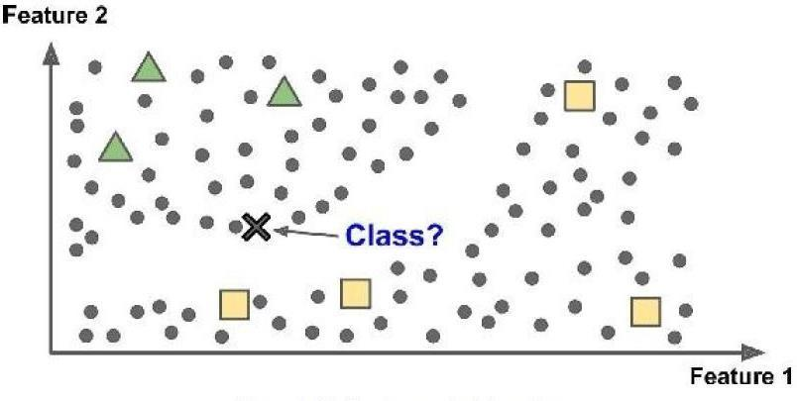

Figure 7:Semi supervised learning

### **2.5.1.2.4. Reinforcement Learning**

Reinforcement Learning is a very different beast. The learning system, called an agent in this context, can observe the environment, select, and perform actions, and get rewards in return (or penalties in the form of negative rewards. It must then learn by itself what is the best strategy, called a policy, to get the most reward over time. A policy defines what action the agent should choose when it is in each situation. (Mitchell, 1997

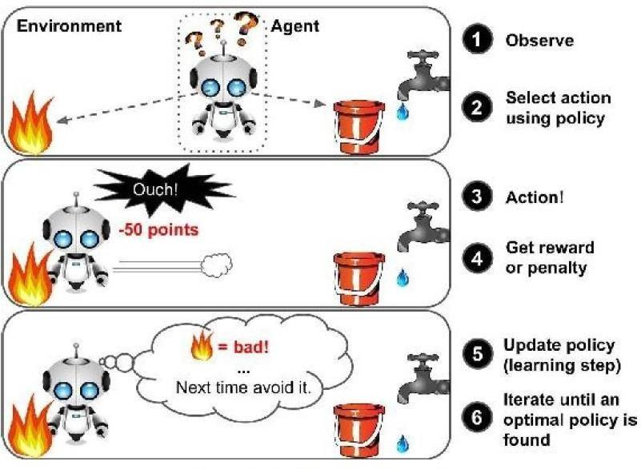

Figure 8:: Reinforcement learning

For example, many robots implement Reinforcement Learning algorithms to learn how to walk. DeepMind’s AlphaGo program is also a good example of Reinforcement Learning: it made the headlines in March 2016 when it beat the world champion Lee Sedol at the game of Go. It learned its winning policy by analyzing millions of games, and then playing many games against itself. Note that learning was turned off during the games against the champion; AlphaGo was just applying the policy it had learned. (Mitchell, 1997)